# Crowdfunding Assignment Report

### Q1: Conclusion

* The success rate of projects overall has been more than 50% mostly. (Figure 1)
* The success rate has been growing at a steady pace throughout the last decade, For e.g., in the early 2010s success rate fluctuated around 55% while in the late 2010s it is around 65%. (Figure 1)
* While average donation in **Technology Sector** has remained stable throughout the decade, the number of backers (sum of people funding) has reduced significantly in the late 2010s. (Figure 2)

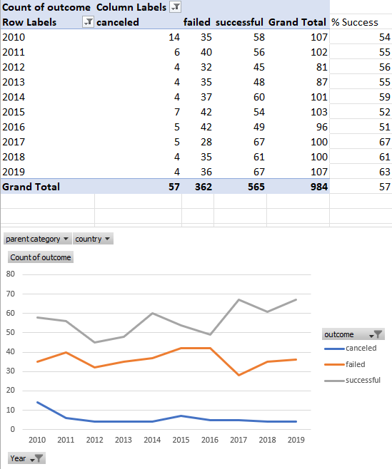

Figure 1

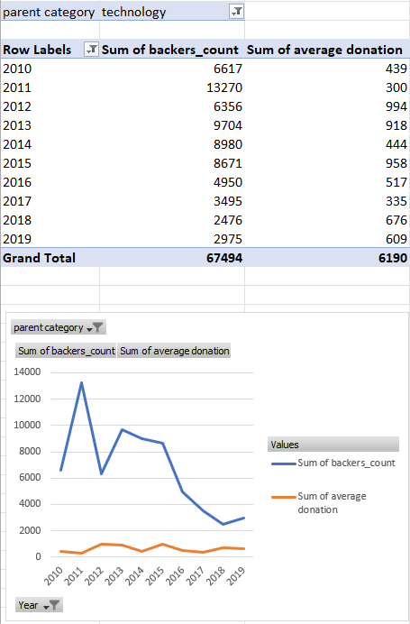

**Figure 2**

### Q2: Limitations of this Dataset

* Dataset for 2020 is not big enough to have accurate trends.
* In this dataset, the data of the USA has overwhelmingly more values than all the other countries combined which results in drastic changes in patterns if we change USA values only. On the other hand, it doesn’t make much difference in the trends if we include/exclude any other country.

### Q3: Other possible tables or Graphs

* We can use a 2D doughnut pie chart to show the contribution of each country in the total pledged amount. It makes it easier to understand. (Figure 3)

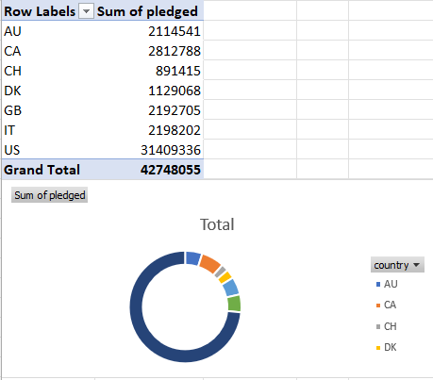

Figure 3

* We can use 3-D stacked bar chart to easily present the number of backers in various categories over the years. (See chart below)